RESUME

Name of candidate – Mohd Sadab
Present Address: Vill+Post-Pilkhani, Distt: Saharanpur
U.P. Pin Code (247232)
Email Id: mohd.sadab42@gmail.com
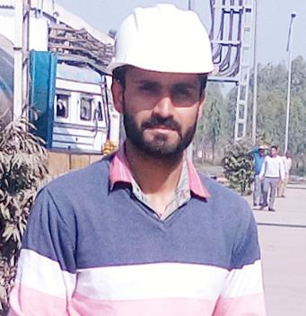
Mobile No.: +91-93170913442 +91-8439659112

CAREER OBJECTIVE
Aim of my life to be successful person in Mechanical sector. To be a part of an organization where I can fully utilize my skills, make a significant contribution to the success of the employer, and at the same time my individual growth.

Work Experience

- Engineering expirence as Maintenance Engineer in NV GROUP OF DISTILLERY & BREWERIES PVT. LTD. Sandharsi Rajpura Punjab from 12 July 2015 to till now.
- DISTILLERY 130 KL
- DDGS DRYER ALFA LAVAL
- DECANTER ALFA LAVAL
- BUHLER MILL
- AGITATOR, GEARBOX, PUMPS
- BELT CONVEYORS, SCREW CONVEYORS, DRAG CHAIN, BUCKET ELEVATORS
- PREVENTIVE MAINTENANCE

EDUCATIONAL QUALIFICATIONS

- B.Tech (Mechanical Engg) from Maharishi markandeshwar university Mullana Ambala | 2010-14 | with CGPA 7.14

- 10+2 | Guru Nanak Inter College, Saharanpur, Uttar Pardesh | 2009-10 | with 65%.
- 10th | Janta Inter College,Ahmadpur brahmin Saharanpur, Uttar Pardesh| 2007-08 | with 60%.
TECHNICAL & COMPUTER SKILLS :

Software & Technologies
- Windows Microsoft Windows XP/7/8/10
- Office Microsoft Office 2003, 2007 and 2010
- Designing Auto Cadd
- Net Surfing and Downloading

Project Title

Solar Sprayer Based On solar plate charging.

Duration: 5 Months .

Hobbies & Interest

- Internet Surfing
- Music, Movies, Reading & Writing.
- Playing Cricket

Language Known

- English
- Hindi
- Urdu

PERSONAL DETAILS

Name : Mr. Mohd Sadab
Father name : Mr. Mohd Saleem
Date of Birth 15/10/1993.
Gender : Male.
Marital Stat : Single
Nationality : Indian
Permanent Address Vil+Post Pilkahni saharanpur Pin Code 247232

DECLARATION

I consider myself familiar with the above-mentioned technologies.
I am also confident of my ability to work in a team and ready to work India and abroad.
I hereby declare that the information furnished above is true to best of my knowledge.

Date:
Place. Mohdsadab

